**🌐 Landing Page**

1. **Customer Overview**
2. **Support & Communication**
3. **News & Updates**
4. **About TSMS**
5. **Login**
6. **Register**

**🔐 Login Page**

1. Username
2. Password (unmasked, visible)
3. Keep me logged in
4. Forgot Password
5. Login Button

**📝 Registration Page**

**Step 1: Personal Information**

* Full Name
* Phone Number
* Business Country
* Region
* Verification Code
* Enter Verification Code
* Checkbox: “I have read and agree to the terms and conditions.”

✅ All fields must be filled and checkbox ticked to continue.

**Step 2: Create Store**

* Store Name
* Desired Password

**Step 3: Store Information Confirmation**

* Store Name
* Password

**📊 Dashboard Overview**

1. **Today’s Sales Performance**
   * Daily Revenue
   * Number of Return Invoices
   * Comparison with:
     + Previous day
     + Same period last month
2. **Monthly Net Revenue**
   * Filter by: Day / Time / Weekday / Custom range
3. **Top 10 Best-Selling Products**
   * By net revenue or quantity
4. **Notifications**
   * Example: Unusual activities, system alerts
5. **Recent Activities**
   * E.g., product imports, sales transactions with values

**📦 Product List Page**

**Product Table Includes:**

* Product Code
* Product Name
* Selling Price
* Cost Price
* Customer Orders
* Creation Time
* Favorite/Star Mark

**Clicking a Product Shows:**

* Product Information
* **Buttons:**
  + Update Info
  + Print Barcode
  + Duplicate Product
  + Discontinue
  + Delete
  + Import Stock
  + Change Product Group

**Functionalities:**

1. Search by Product Code or Name
2. Add New Product
3. Export Product List
4. Filter by Product Group (e.g., Laptop, Phone, Headphones…)
5. Inventory Filter:
   * In Stock
   * Out of Stock
   * Overstock
6. Filter by Supplier (e.g., Apple, Marshall…)
7. Filter by Warranty Availability

**💰 Price Settings Page**

**Table Includes:**

* Product Code
* Product Name
* Cost Price
* Last Purchase Price
* General Price List



**Same Functionalities as Product List:**

1. Search by Product Code or Name
2. Add New Product
3. Export Product List
4. Filter by Product Group
5. Inventory Filter
6. Supplier Filter
7. Warranty Filter

**🛠️ Warranty Page**

**Table Includes:**

* Product Code
* Product Name
* Purchase Invoice
* Customer
* Remaining Warranty Time

**Filters:**

1. Purchase Date Selection
2. Warranty Status:
   * All
   * Valid
   * Expired

**📋 Inventory Check Page**

**Table Includes:**

* Inventory Check ID
* Date
* Actual Quantity
* Total Actual Value
* Total Difference
* Quantity Differences (Increase/Decrease)
* Notes

**Filters:**

1. Time Period: This month or custom date range
2. Status:
   * Temporary
   * Stock Balanced
   * Cancelled
3. Created By

**👥 Customer Management Page**

**Table Includes:**

* Customer Code
* Customer Name
* Phone Number
* Total Sales
* Net Sales (after returns)

**Functionalities:**

1. Add New Customer
2. Filter by Birthday
3. Filter by Last Transaction Date
4. Total Revenue from Customer (with time filter)
5. Customer Type: All / Individual / Company
6. Gender Filter

**🏢 Supplier Management Page**

**Table Includes:**

* Supplier Code
* Supplier Name
* Phone Number
* Email
* Total Purchase Value

**Filters:**

1. Supplier Group
2. Total Purchase Value (with time range)

**👨‍💼 Employee Management Page**

**Table Includes:**

* Employee Code
* Timekeeping Code
* Name
* Phone Number
* ID Card Number (CCCD)
* Notes

**Filters:**

1. Employment Status: Working / Resigned
2. Assigned Branch
3. Payroll Branch
4. Additional Functions

**📅 Daily Analysis Page**

**Data Table Includes Filters For:**

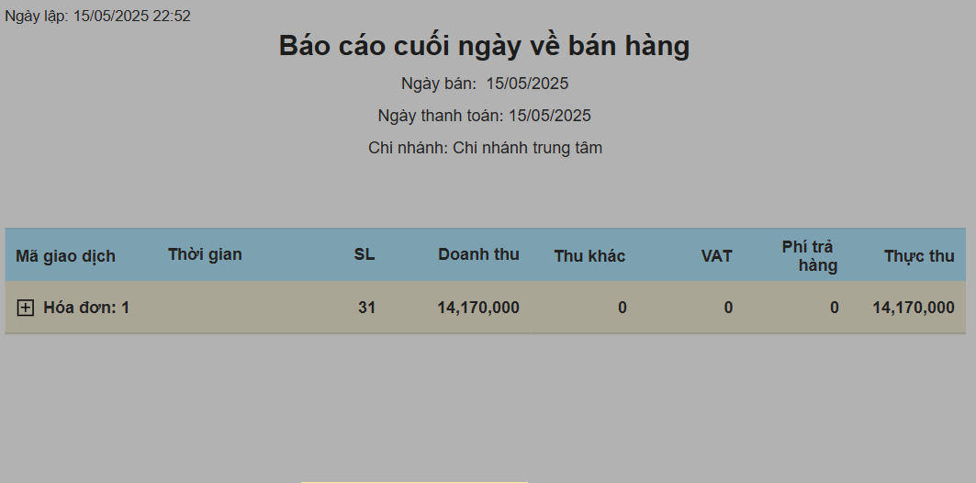

1. Focus Area:
   * Sales
   * Incomes & Expenses
   * Inventory
   * Overall Summary
2. Time Range
3. Customer
4. Salesperson
5. Created By
6. Payment Method

**📈 Product Analysis Page**

**Charts & Graphs:**

* Products with highest revenue
* Products with highest sales quantity

**Filters:**

1. Focus Area
2. Time Period
3. Product
4. Product Type
5. Product Group

**🧾 Order Creation Page**

1. Product Search Bar
2. Add Invoice
3. Selected Products Display:
   * Check product availability in current branch
   * If out of stock, check other branches
4. Select Cashier on Shift
5. Total Product Value
6. Discount
7. Amount to Pay
8. Amount Received from Customer
9. Change to Return
10. Image-Based Product Search
11. Filter by Product Group
12. Feedback
13. User Guide